Signals

- What is the purpose of expressing an AC signal as an RMS value?

To give an AC value a relatable comparison to DC voltages and currents.
The AC RMS value is equivalent to DC value that would give the same heating effect (i.e. through a resistance).

- What factors affect the reliable transmission of a signal through a communications channel?

Noise and interference are the major factors. Other factors include attenuation in transmission lines, phasing effects, jitter in timed digital transmission lines.

- How many 12kHz channels can be multiplexed into a 120kHz frequency band?

10

- How many compressed channels can be multiplexed into a 120kHz channel (discuss …)

Open ended discussion!
It depends on the level of compression used.
However, transmission channels are subject to a Shannon maximum effect which is not really to do with compression itself, but is the limit of data/information possible in a channel with given transmission parameters (modulation level, etc) and the noise level (signal/noise ratio) in that channel

- Explain the occurrence and effect of jitter in a communications channel.

inaccuracies in electronic timing circuits in transmission or receiver devices
electromagnetic interference
crosstalk with carriers of other signals
tolerable jitter - depends on the affected application

- What is meant by “symbols” in data transmission?

A symbol is the single element of data to be transmitted as specified for a specific data link.
For digital transmission a symbol may consist of one or more bits as determined by the modulation format
Examples
In a BPSK. system, each symbol represents 1 bit
QPSK Quadrature phase shift keying, symbol represents 2 bits
etc
64QAM: 64 distinct symbols; i.e. 2^6 = 64; i.e. 6 bits/symbol

- What is intersymbol interference in (a) a pulsed digital channel and (b) a radio transmission channel where data is sent as symbols represented on a carrier?

The distortion of the signal when one symbol interferes with subsequent symbols
Caused by data spread (e.g. phase distortions causing the signal to extend) in transmission media
Also caused by reflections in radio transmissions, specifically causing multipath effects, resulting in the signal (symbol) and its reflections to arrive at the receiver at different times (the direct signal being the first to arrive). Subsequent reception of reflections of the same signal will add to the received signal (constructivey or destructively) to cause potentially ambiguous symbols requiring decoding.
A typical method of avoiding this is to allow a guard time between symbols. This will slightly reduce the data carrying bandwidth of the channel (i.e. if the channel was perfect), but will aleviate the ISI problem which would otherwise reduce the effective transmission efficacy of the channel either due to the requirement for retransmissions, or in data being irretrievable lost. (However, lost data may be further safe-guarded (to a certain extent) by the other techniques, e.g. FEC).

- What is an eye diagram and what performance characteristics does it diagnose in a communications channel?

An eye diagram can demonstrate the performance of a data channel.
Repeated binary signals can build up a “history” of reception which, when “overlaid” in time can demonstrate the effect of:
Noise – demonstrated by the amount of overlap of signals reducing the apparent height between binary 1 and binary 0
Jitter – demonstrated by the rising and falling edges of the data thickening the vertical edges of the pulses.

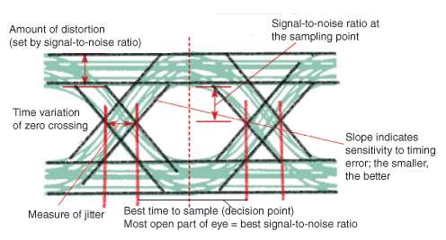

- Express the following in binary and hexadecimal:
Dec Bin Hex
- 7 0111 7
- 23 10111 17
- 67 1000011 43
- 123 1111011 78
- 1007 1111101111 3EF

Express the following in base 10 (standard decimal) numbering
Bin Hex Dec
- 1001 9 9
- 1100 C 12
- 10001 11 17
- 10101 15 21
- 11000 18 24

Hex Dec Bin
- #9A 154 10011010
- #BC 188 10111100
- #29 41 101001
- #45 69 1000101
- #4C 76 1001100

